Computer Networks

Submitted by ritwik and nilesh

Project 2

Use Case

The main focus of this project is to create a Decentralized Appstore which will be based on peer to peer application transfer. Peers can transfer application file on that network. Every peer on that network will have unique ID in order to identify peer and for security purpose. As of now we have created network between two people and short range. Lets say there are two people in a network and they want to share any application file eg.Apk file. We will be using TCP protocol in this network for sharing. TCP (transmission control protocol) will start making connection between peers and application will start transferring.

Diagram

In this project we are using the concept of peer to peer network in order to show communication between peers. 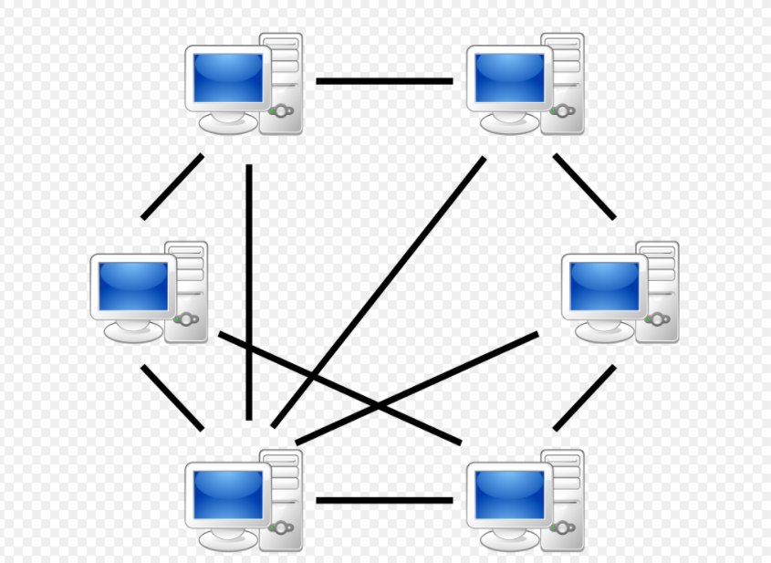

Fig 1.1 P2P diagram

Functional Description

TCP is connection oriented protocol. it first establishes the connection then data then the transfers file. where as in UDP it is not connection oriented it just send the data and does not inquire whether the data(file) is transferred or not. In order to show proper communication we are using TCP protocol.

In this project we also used the concept of client and server using python. we have created two file one is Client.py and the other is Server.py. Both server and client can act as sender and receiver. Due to the peer to peer concept these both will act according to the situation.

Algorithms

Networking Model

In this project we are using the concept of on peer to peer network and we are converting the Client server based model into peer to peer network.

TCP is connection oriented protocol. it first establishes the connection then data then the transfers file. where as in UDP it is not connection oriented it just send the data and does not inquire whether the data(file) is transferred or not. In order to show proper communication we are using TCP protocol.

In future we will use UDP as It provides great connection speed as compared to TCP. File Transfer speed of UDP is also very Fast.

Other Consideration

Right now we are transferring file from close contact so when receiver will type unique IP address it will get connected with sender. So it is secure way to send to application file .In future we are planning more secure when we will increase the transfer range. if any new peer joins the network then he would be provided with unique identity and password. so that all the peer on the network remain anonymous. Network will contain 2 factor authentication for security purpose.

Implementation Details

* Sender gets the unique IP-address
* Port is specified
* Receiver is asked to enter the IP for connection
* Connection completed
* Sender is asked to choose the app

Highlights

We were able to make close contacts application file transfer system. We used python for coding and we implemented socket programming algorithm to make connection between peers. In future we are planning to increase the range of file transfer by using the hybrid of TCP and UDP. And we also wanted to implement IPFS(interplanetary file system ).

IPFS is file sharing system protocol It stores data efficiently and It is also used for transferring large file . It also helps in storing data centrally and has efficient wide range for file transfer.

Changes from project 1

In first project we had one central list of Combined application from every peer that are present on that network. Whereas in this project we are just sending specific file which is requested by the peer. In project 2 we were able to achieve close contact application file transfer. In project create code and we established practical connection between peers. where as in 1st project we just wrote the algorithm for the application file transfer. We have created a basic model for application transfer and shown communication between two peers.